[](https://www.genmymodel.com/)

# ERDigram

ClassDigram

Author: PrashantVishwakarma

Date: 2022-09-26

# ERDigram (Model)

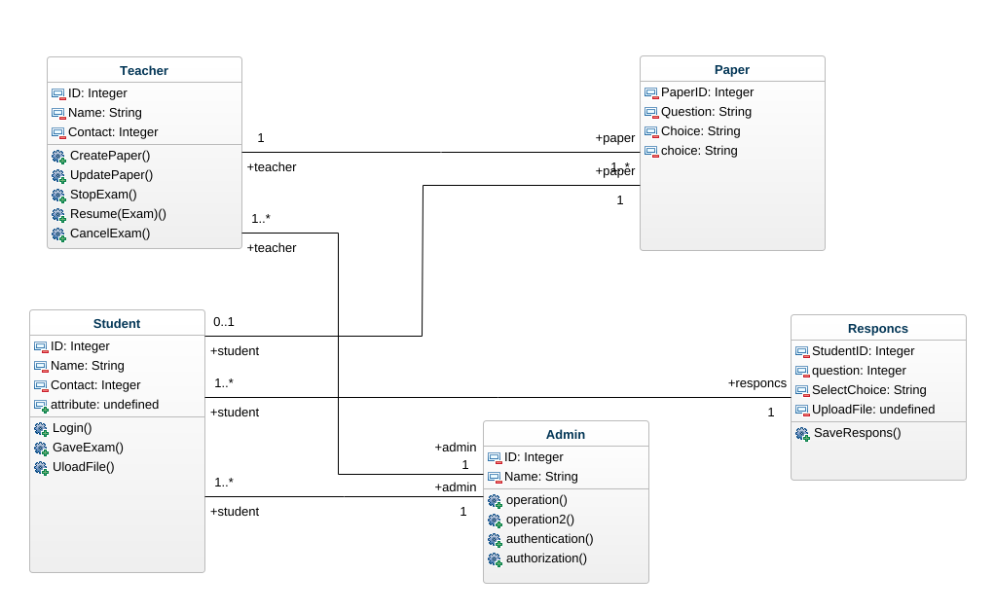

object-diagram

## 1. Admin (Class)

In ERDigram

| Attributes |
| --- |
| ID : Integer [1] |
| Name : String [1] |
| attribute : invalid [1] |
| attribute2 : invalid [1] |
| : invalid [1] |

| Operations |
| --- |
| operation |
| operation2 |
| authentication |
| authorization |

| Associations |
| --- |
| Teacher_Admin - teacher : Teacher [0..1] - see definition |
| Student_Admin - student : Student [1..*] - see definition |
| Teacher_Admin2 - teacher : Teacher [1..*] - see definition |

## 2. Class (Class)

In ERDigram

## 3. InstanceSpecification (InstanceSpecification)

In ERDigram

## 4. Paper (Class)

In ERDigram

| Attributes |
| --- |
| PaperID : Integer [1] |
| Question : String [1] |
| Choice : String [1] |
| choice : String [1] |
| attribute5 : invalid [1] |
| fileUplaod : invalid [1] |

| Associations |
| --- |
| Paper_Student - student : Student [0..1] - see definition |
| Teacher_Paper - teacher : Teacher [1] - see definition |

## 5. Responcs (Class)

In ERDigram

| Attributes |
| --- |
| StudentID : Integer [1] |
| question : Integer [1] |
| SelectChoice : String [1] |
| UploadFile : invalid [1] |
| attribute5 : invalid [1] |
| attribute6 : invalid [1] |

| Operations |
| --- |
| SaveRespons |

| Associations |
| --- |
| Student_Responcs - student : Student [1..*] - see definition |

## 6. Student (Class)

In ERDigram

| Attributes |
| --- |
| ID : Integer [1] |
| Name : String [1] |
| Contact : Integer [1] |
| attribute : invalid [1] |

| Operations |
| --- |
| Login |
| GaveExam |
| UloadFile |

| Associations |
| --- |
| Student_Responcs - responcs : Responcs [1] - see definition |
| Student_Admin - admin : Admin [1] - see definition |
| Paper_Student - paper : Paper [1] - see definition |

## 7. Teacher (Class)

In ERDigram

Extends

* Paper - see definition

| Attributes |
| --- |
| attribute : invalid [1] |
| attribute2 : invalid [1] |
| attribute3 : invalid [1] |
| attribute4 : invalid [1] |
| attribute5 : invalid [1] |
| attribute6 : invalid [1] |
| attribute7 : invalid [1] |
| attribute8 : invalid [1] |
| attribute9 : invalid [1] |
| attribute10 : invalid [1] |
| attribute11 : invalid [1] |
| ID : Integer [1] |
| Name : String [1] |
| Contact : Integer [1] |
| : invalid [1] |
| attribute12 : invalid [1] |

| Operations |
| --- |
| CreatePaper |
| UpdatePaper |
| StopExam |
| Resume(Exam) |
| CancelExam |

| Associations |
| --- |
| Teacher_Admin - admin : Admin [0..1] - see definition |
| Teacher_Admin2 - admin : Admin [1] - see definition |
| Teacher_Paper - paper : Paper [1..*] - see definition |